# **Name: Abdurrahman Qureshi**

# **Roll No: 242466**

Assignment No: 1

**Topic: College Management System ER Diagram**

Steps to Create an ER Diagram:

Step 1: Identifying objective of the system

* Manage student details and link them to admissions for seamless tracking.
* Track student enrolments, courses, and admission dates efficiently.
* Coordinate faculty and schedule timetables for streamlined class management.

Step 2: Identify Entities and Attributes

* Student: Name, Phone_Number, Email.
* Admission: Student_Number, Course, Date, Year.
* Faculty: Name, Phone_Number, Type.
* Timetable: Time, Day.
* Subjects: Type, Code.

Defining attributes for each entity:

Student Entity:

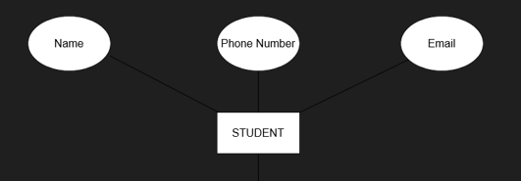

Admission Entity:

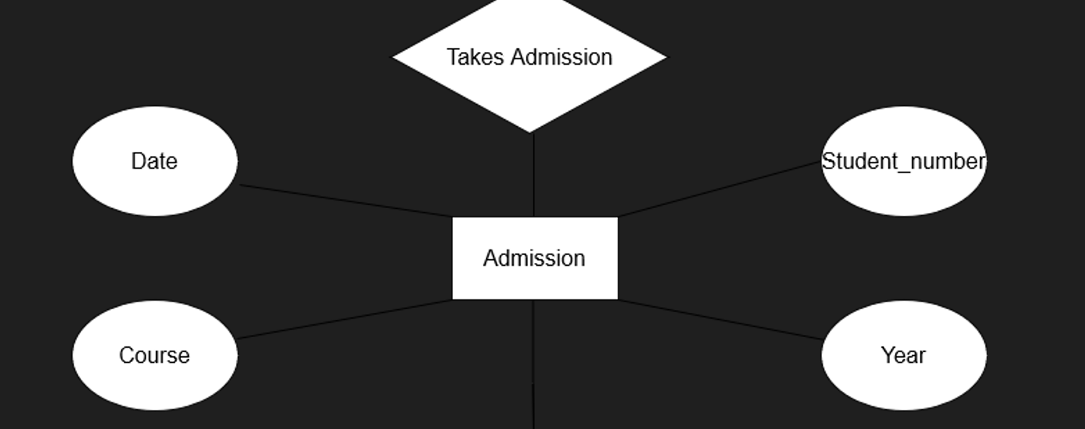

Time Table Entity:

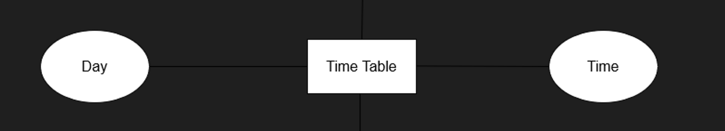

Subjects Entity:

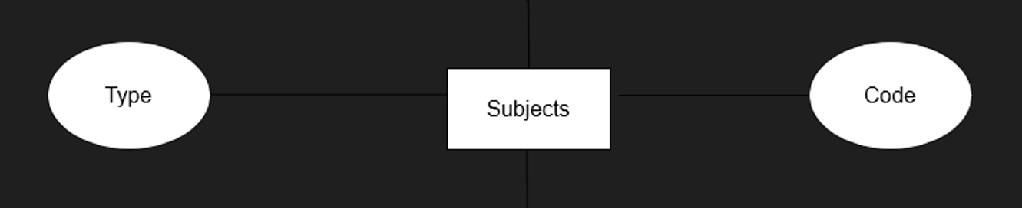

Faculty Entity:

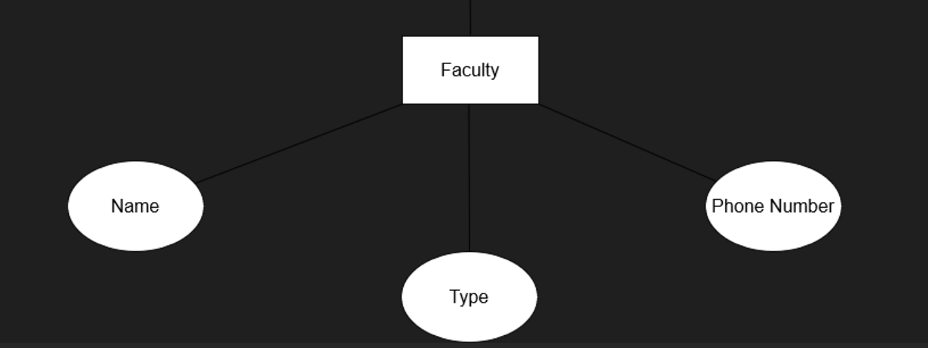

Step 3: Establishing Relationships

Identifying relationships between entities, such as:

* Student and Admission: Students take admission in courses.
* Lecturer and Lectures: Lecturers conduct various lectures.
* Lectures and Subjects: Lectures correspond to specific subjects.
* Admission and Timetable: After admission, a student's classes are scheduled on the timetable.

Establishing Relationships:

Take Admission:

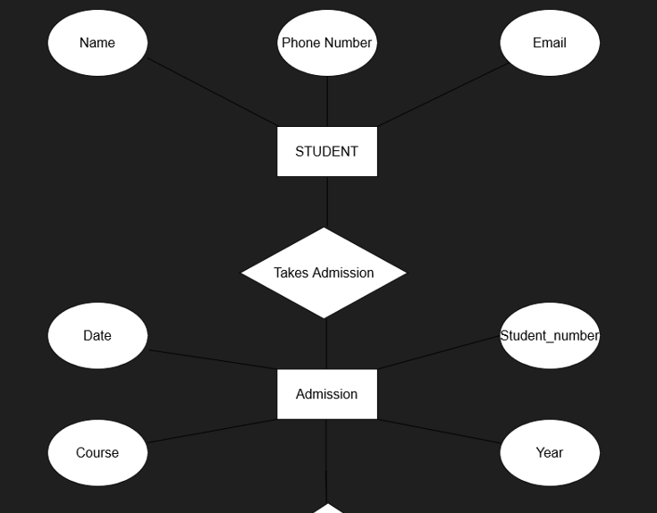

Gets Allotted:

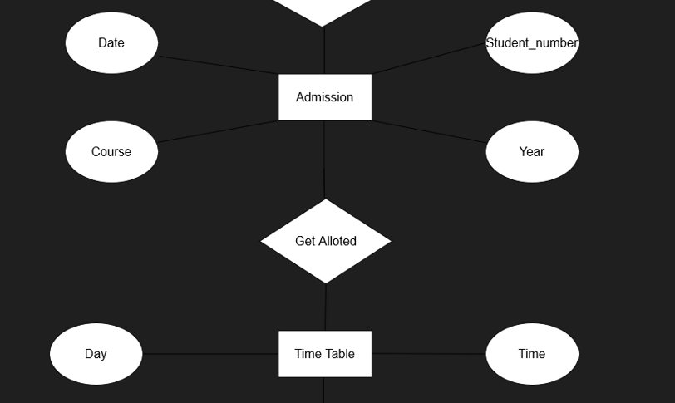

Slots:

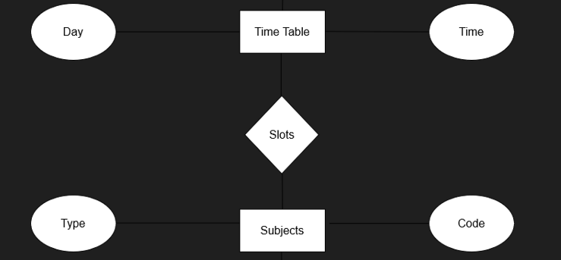

Teaches:

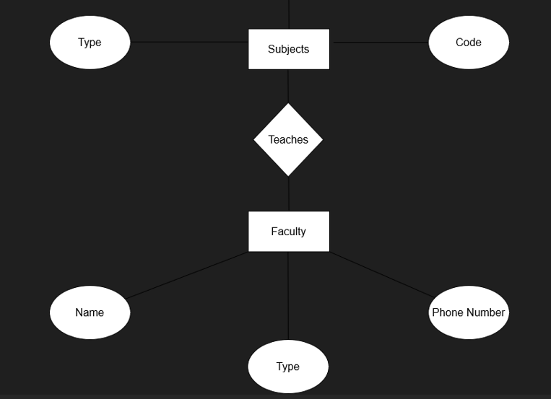

Step 4: Set Cardinality

Determining the cardinality of relationships:

* Student - Admission (Takes Admission)

1 to Many (1): A single student can have multiple admissions (e.g., to different courses), but an admission belongs to one student.

* Admission - TimeTable (Get Allotted)

Many to Many (M): Multiple admissions can be associated with multiple timetables (students can be assigned to various classes at different times).

* TimeTable - Subjects (Slots)

1 to Many (1): One timetable can have multiple subjects scheduled at different times, but a subject in the timetable is associated with one slot.

* Subjects - Faculty (Teaches)

Many to 1 (N:1): Multiple subjects can be taught by one faculty member, but a subject has only one faculty teaching it.

Cardinality:

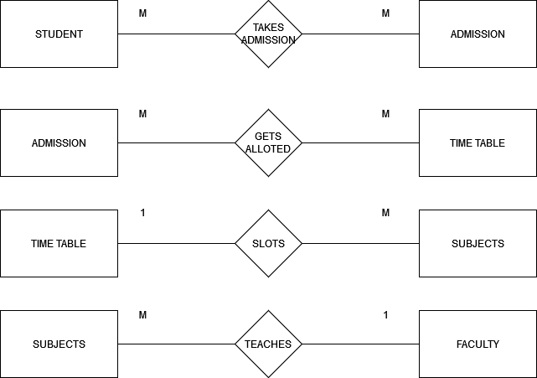

Step 5: Drawing the Diagram

* Use rectangles to represent entities.
* Use ovals for attributes.
* Use diamonds to represent relationships.
* Connecting entities with relationships using lines and indicate cardinality (1:1, 1, M).

Drawing the Diagram:

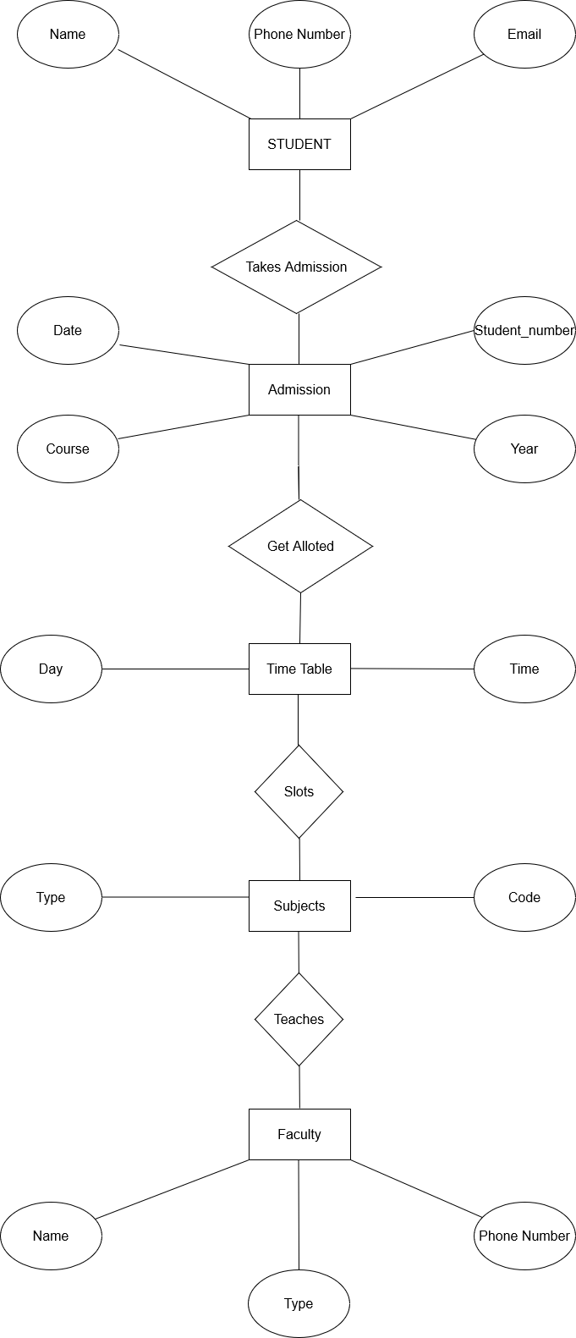

Step 5: Converting the ER Diagram into a table

**Students:**

* Name
* Email
* Phone_Number

**Faculty:**

* Name
* Type
* Phone_Number

**Course:**

* Code
* Type

**Admission:**

* Date
* Student_number
* Year
* **Course**

**Time Table:**

* Day
* Time

Table Creation:

* Student:

CREATE TABLE assStudent (

student_id INT PRIMARY KEY AUTO_INCREMENT,

name VARCHAR(100) NOT NULL,

phone_number VARCHAR(15),

email VARCHAR(100) UNIQUE

);

* Admission:

CREATE TABLE assAdmission (

admission_id INT PRIMARY KEY AUTO_INCREMENT,

student_number INT NOT NULL,

course VARCHAR(100) NOT NULL,

admission_date DATE,

admission_year INT,

FOREIGN KEY (student_number) REFERENCES assStudent(student_id)

);

* Faculty:

CREATE TABLE assFaculty (

faculty_id INT PRIMARY KEY AUTO_INCREMENT,

name VARCHAR(100) NOT NULL,

phone_number VARCHAR(15),

type VARCHAR(50) NOT NULL

);

* Timetable:

CREATE TABLE assTimetable (

timetable_id INT PRIMARY KEY AUTO_INCREMENT,

time TIME NOT NULL,

date DATE NOT NULL

);

* Subjects:

CREATE TABLE assSubjects (

subject_id INT PRIMARY KEY AUTO_INCREMENT,

type VARCHAR(100) NOT NULL,

code VARCHAR(10) UNIQUE NOT NULL

);

